


CAPSTONE PROJECT REPORT
Report 6 – Software User Guides

– Ho Chi Minh City, August 2026 –

CONTENTS
I. Record of Changes 3
II. Release Package & User Guides 4
1. Deliverable Package 4
2. Installation Guides 4
2.1 System Requirements 4
2.2 Installation Instruction 7
3. User Manual 10
3.1 Overview 10
3.2 Workflow 1: HR – Upload and Ingest Knowledge Base Document 11
3.3 Workflow 2: HR – AI-Powered Interview Question Generation 13
3.4 Workflow 3: HR – Ask AI (Chat-Assisted Question Refinement) 15
3.5 Workflow 4: HR – Manual Question Builder 16
3.6 Workflow 5: HR – Invite Candidate to Practice 18
3.7 Workflow 6: HR – Candidate Overview and AI Recommendation 19
3.8 Workflow 7: Candidate – Upload and AI Parse CV 21
3.9 Workflow 8: Candidate – Browse Marketplace and Start Practice Session 24
3.10 Workflow 9: Candidate – AI Evaluation and Feedback (Freemium vs Premium) 25
3.11 Workflow 10: Candidate – Dashboard and Practice History 27
3.12 Workflow 11: Admin – Knowledge Base Oversight and RAG Status Monitoring 29
3.13 Workflow 12: Subscription Upgrade and SePay Payment (Realtime Confirmation) 30

I. Record of Changes
Date | A* M, D | In charge | Change Description
01/07/2026 | A | All | First version — Software User Guides for IQGS (System Requirements, Installation, User Manual)
08/07/2026 | A | KhoaHD | Added System Requirements and Installation Instruction (Backend, RAG Service, Frontend setup)
10/07/2026 | A | NamNM | Added User Manual Overview and Workflow 1–3 (Knowledge Base Ingestion, AI-Powered Question Generation, Ask AI)
15/07/2026 | A | TuPT | Added Workflow 4–7 (Manual Question Builder, Invite Candidate, Candidate Overview & AI Recommendation, CV Parsing)
18/07/2026 | A | HienNT | Added Workflow 8–12 (Marketplace, AI Evaluation & Feedback, Dashboard, Admin Oversight, Subscription Payment) and Deliverable Package
30/07/2026 | M | NamNM | Revised Workflow 1–2 diagrams and description after RAG ingestion pipeline refactor
08/08/2026 | M | HienNT | Updated Workflow 9 and 12 (AI Evaluation Freemium/Premium, SePay Payment) after webhook signature and subscription tier adjustments
16/08/2026 | M | All | Final review and consistency pass across all workflow sections before submission
*A - Added M - Modified D - Deleted

II. Release Package & User Guides

1. Deliverable Package
No. | Deliverable Item | Description
1 | Project Backlog | Jira SCRUM Board (Sprint Backlog)
2 | Source Codes (FE) | AI_Interview_Question_Generation_RAG_LLM_FE (Next.js)
3 | Source Codes (BE) | IQGS-SEP490-Backend (ASP.NET Core 8)
4 | Source Codes (RAG Service) | RAG (Python / FastAPI)
5 | Final Report Document | Report7_Final Project Report.docx
6 | Test Cases Document | Report5_Test Documentation.docx

2. Installation Guides

2.1 System Requirements
- Hardware:
    - Minimum 8 GB RAM (16 GB recommended when running Ollama locally)
    - At least 10 GB of free disk space
    - Stable internet connection (cloud LLM, Azure Blob, SePay gateway)
- Software: Windows 10/11, Linux or macOS
    - Docker Desktop
    - .NET 8 SDK
    - Node.js 20+ and npm 10+
    - Python 3.11+
    - Ollama runtime (local LLM + embedding models)
- Runtime:
  - Backend (ASP.NET Core 8, target framework net8.0):
  - .NET / WebAPI layer
    - Microsoft.EntityFrameworkCore.Design 8.0.0
    - Swashbuckle.AspNetCore 6.6.2 (Swagger / OpenAPI)
    - Microsoft.AspNetCore.Authentication.JwtBearer 8.0.0
    - Hangfire.AspNetCore 1.8.17
    - Hangfire.PostgreSql 1.20.10
    - Pgvector.EntityFrameworkCore 0.2.0
    - Npgsql 8.0.3
    - FluentValidation.AspNetCore 11.3.0
    - Serilog.AspNetCore 8.0.2, Serilog.Sinks.Console 5.0.1, Serilog.Sinks.File 5.0.0
  - Application layer
    - BCrypt.Net-Next 4.0.3 (password hashing)
    - Google.Apis.Auth 1.68.0 (Google OAuth)
    - FluentValidation 11.11.0
    - MailKit 4.10.0 (SMTP email)
    - ClosedXML 0.104.2 (Excel export)
  - Infrastructure layer
    - Microsoft.EntityFrameworkCore 8.0.0, Npgsql.EntityFrameworkCore.PostgreSQL 8.0.0
    - Azure.Storage.Blobs 12.23.0 (knowledge documents, CVs, image hints)
    - Hangfire.Core 1.8.17
    - UglyToad.PdfPig 1.7.0-custom-5 (PDF text extraction)
    - DocumentFormat.OpenXml 3.2.0 (DOCX parsing)
  - Domain layer
    - AutoWrapper.Core 4.5.1 (uniform API response wrapper)
    - Pgvector 0.2.0
  - Frontend (Next.js 16 / React 19):
  - Framework / build
    - next 16.2.6 (App Router)
    - react 19.2.4, react-dom 19.2.4
    - typescript ^5
  - Styling
    - tailwindcss ^4, @tailwindcss/postcss ^4
    - class-variance-authority 0.7.1, clsx 2.1.1, tailwind-merge 3.5.0
  - HTTP / Auth / Realtime
    - axios 1.16.1
    - @react-oauth/google 0.13.5 (Google OAuth)
    - @microsoft/signalr 10.0.0 (payment realtime hub)
  - UI / UX
    - lucide-react 1.8.0, react-icons 5.6.0
    - framer-motion 12.38.0
    - @dnd-kit/core, @dnd-kit/sortable, @dnd-kit/utilities
  - Data
    - recharts 3.8.1 (dashboard charts)
    - xlsx 0.18.5 (export)
  - RAG Service (Python 3.11+, FastAPI):
    - fastapi, uvicorn[standard] (API layer)
    - openai>=1.60.0 (Ollama OpenAI-compatible client)
    - psycopg[binary,pool]>=3.2, pgvector>=0.3 (PostgreSQL + vector similarity search)
    - pdfplumber==0.11.4, python-docx==1.1.2 (document parsing)
    - pydantic>=2.0, pydantic-settings>=2.0 (schemas & config)
    - numpy>=2.0.0, httpx>=0.27, python-dotenv, python-multipart
    - pytest>=8.0 (tests)

2.2 Installation Instruction
- Backend (ASP.NET):
- Clone the repository and open IQGS-BE.sln.
git clone <backend-repository-url>
- Start PostgreSQL.
docker compose up -d postgres
If a plain postgres:16 image is used, enable pgvector once: CREATE EXTENSION IF NOT EXISTS vector;
- Configure WebAPI/appsettings.Development.json (or dotnet user-secrets).
ConnectionStrings:DefaultConnection, JwtSettings, GoogleOAuth:ClientId, EmailSettings (SMTP), RagService:BaseUrl, BlobStorage connection string, SePay settings, InternalApi:Key.
- Apply EF Core migrations (the app also auto-migrates on startup).
dotnet ef database update --project InfrastructureLayer --startup-project WebAPI
- Run the API.
dotnet run --project WebAPI
API: http://localhost:5248 (HTTPS https://localhost:7052). Swagger: /swagger. Hangfire dashboard: /hangfire.
- Seeded accounts for first login.
Admin: admin@iqgs.com / adminiqgs — HR: hr@iqgs.com / hriqgs — Candidate: candidate@iqgs.com / candidateiqgs
RAG Service (Python / FastAPI):
- Create a virtual environment and install dependencies.
cd RAG
python -m venv .venv
.venv\Scripts\activate (Windows)
pip install -r requirements.txt
- Configure environment variables.
Copy .env.example to .env and set DATABASE_URL (same PostgreSQL as Backend), BACKEND_INTERNAL_BASE_URL, INTERNAL_API_KEY (must match the Backend's InternalApi:Key), OLLAMA_BASE_URL, CHAT_MODEL, EMBEDDING_MODEL.
- Pull the required Ollama models.
ollama pull nomic-embed-text
ollama pull gemma4b:cloud (or the model configured in CHAT_MODEL)
- (Dev only) create the knowledge_chunks table if missing.
psql $DATABASE_URL -f scripts/init_knowledge_chunks.sql
- Start the service.
.\run-local.ps1 (Windows, recommended)
python -m uvicorn api.app:app --host 0.0.0.0 --port 8000 --reload
- Health check.
curl http://localhost:8000/health
Frontend (Next.js 16):
- Install dependencies.
cd FE/AI_Interview_Question_Generation_RAG_LLM_FE
npm install
- Configure environment variables.
Copy .env.example to .env.local and set NEXT_PUBLIC_API_BASE_URL, NEXT_PUBLIC_RAG_BASE_URL, NEXT_PUBLIC_GOOGLE_CLIENT_ID, NEXT_PUBLIC_CLOUDINARY_CLOUD_NAME, NEXT_PUBLIC_CLOUDINARY_UPLOAD_PRESET.
- Run the development server.
npm run dev
Go to: http://localhost:3000

3. User Manual

3.1 Overview
IQGS (Interview Question Generation System) is a dual-sided, AI-driven recruitment platform that connects HR recruiters and job seekers around a single asset: a high-quality bank of interview questions. Designing good, role-specific interview questions is time-consuming for HR teams, which often leads to reused, generic question lists that do not match the actual requirements of the role being hired for.

IQGS addresses this by combining Retrieval-Augmented Generation (RAG) with a Large Language Model (LLM). HR recruiters submit a Job Description; the system retrieves relevant context from a curated Knowledge Base (industry standards such as SWEBOK/ACM, plus HR's own uploaded materials) and uses it to generate an interview plan and a tailored set of interview questions. On the other side of the platform, job seekers browse published question sets, practice in timed simulations, and receive AI-generated feedback on their answers — closing the loop between better questions and better-prepared candidates.

The platform is built around three cooperating components: the Frontend (Next.js web application for Admin, HR and Candidate users), the Backend (ASP.NET Core 8, Clean Architecture — orchestrates authentication, business rules, persistence, background jobs and file storage), and the RAG Service (Python / FastAPI — a stateless, internal-only microservice for document chunking, embedding, vector retrieval and LLM-based generation, reachable only from the Backend through a shared internal API key).

IQGS supports three user roles: Administrator (manages users, companies, Knowledge Base and RAG health, subscription plans), HR Manager / Recruiter (uploads Job Descriptions, generates or manually builds question sets, manages a private Knowledge Base, invites candidates, reviews AI recommendations), and Job Seeker / Candidate (browses question sets, uploads a CV for AI parsing, practices in timed sessions, receives AI feedback, tracks progress).
The following sections describe, in detail, the twelve most representative workflows of the system — the ones that best illustrate how the AI/RAG pipeline, the background job system and the three user roles work together in practice.

3.2 Workflow 1: HR – Upload and Ingest Knowledge Base Document
Description: This process describes how an HR user enriches the RAG Knowledge Base with reference material (job standards, internal rubrics, past question banks). The HR user uploads a PDF, DOCX or TXT file from the Knowledge Base page; the Backend stores the original file in Azure Blob Storage and creates a knowledge_documents record with status QUEUED, then schedules a KnowledgeIngestJob on the dedicated knowledge-ingestion Hangfire queue so the upload request returns immediately. In the background, the RAG Service downloads the file through a time-limited Blob SAS URL, reports status PROCESSING, parses and splits the document into overlapping chunks, and embeds each chunk with Ollama. If parsing or embedding fails, the RAG Service reports status FAILED with an error message (and a watchdog job also reclaims documents stuck in PROCESSING for too long); otherwise the embeddings are written to PostgreSQL (pgvector) and the document is marked COMPLETED with its resulting chunk count, becoming available for future retrieval.
Workflow Diagram:
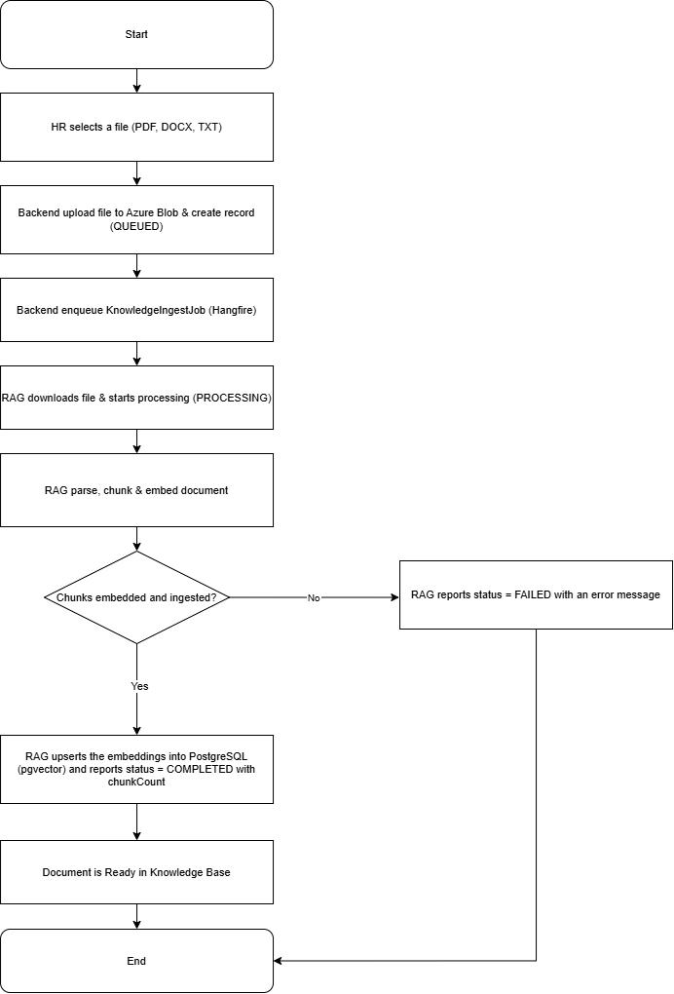

3.3 Workflow 2: HR – AI-Powered Interview Question Generation
Description: This is the platform's core workflow. The HR user enters or uploads a Job Description together with generation parameters (number of questions, difficulty, question types, required skills) and submits a generation request. If the request is invalid (JD too short, missing fields), the Backend returns a validation error and the HR user corrects the form. Otherwise, the Backend creates a Job, queues it as a Hangfire background task, and the RAG Service retrieves relevant Knowledge Base context and asks the LLM to draft an Interview Plan; on failure the HR user can retry plan generation without resubmitting the Job Description. Once the plan is ready, the HR user reviews and edits it (role, skills, question-type distribution, difficulty) and clicks Approve Plan. The Backend then asks the RAG Service to generate the actual interview questions from the approved plan; again, failures can be retried independently of the plan step. When question generation succeeds, the HR user reviews the generated questions — editing, adding, deleting or reordering them — and finally clicks Save Draft to persist the finished Question Set, after which further edits through this flow are locked.
Workflow Diagram:
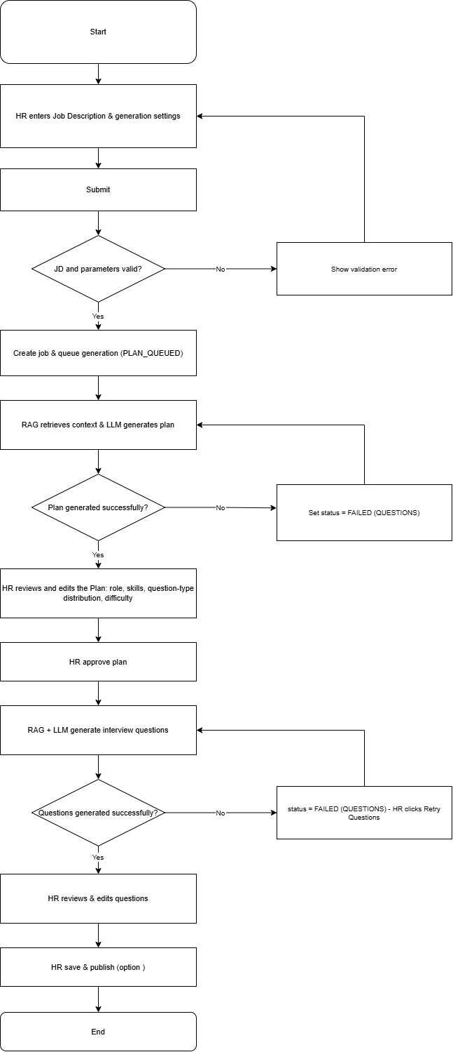

3.4 Workflow 3: HR – Ask AI (Chat-Assisted Question Refinement)
Description: This process lets an HR user fine-tune an individual generated question through a short AI conversation instead of editing it manually. From the Studio question list, the HR user opens a question and types a request in the Ask AI chat panel (for example, asking for a harder variant or a system-design angle). The Backend assembles the relevant context — the original Job Description, the interview plan, the current question, the target skills and difficulty, and the chat history — and forwards it to the RAG Service's question-assist endpoint, which uses the LLM directly without an additional vector search. The RAG Service returns a conversational reply together with a concrete suggested question, rationale, sample answer and difficulty. The HR user can accept the suggestion, which overwrites the question and marks it as manually edited, or continue the conversation to refine it further.
Workflow Diagram:
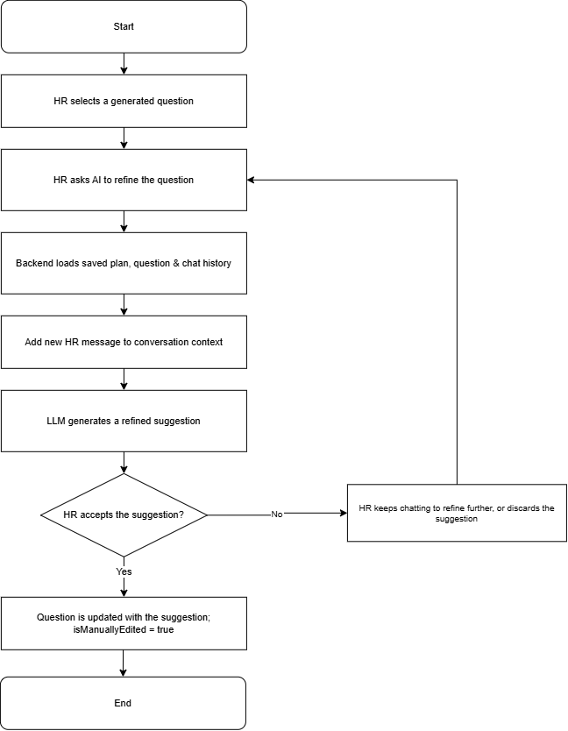

3.5 Workflow 4: HR – Manual Question Builder
Description: This process describes how an HR user creates an interview question set without relying on AI generation, useful for highly specific or proprietary question content. The HR user opens the Question Builder, creates a new Question Set with a title and target role, then adds questions one at a time, specifying content, type, difficulty, target skill, sample answer and evaluation criteria. Optionally, an image hint can be attached to a question, which is uploaded and stored in Azure Blob Storage. The HR user can drag and drop to reorder the question list at any time, and repeats the add-question step until the set is complete, finally publishing or saving the Question Set.
Workflow Diagram:
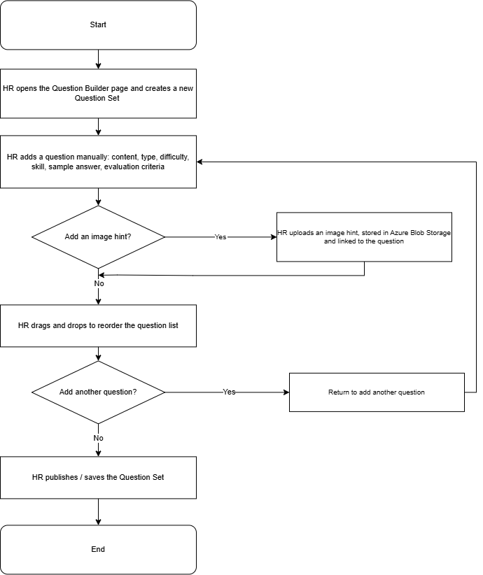

3.6 Workflow 5: HR – Invite Candidate to Practice
Description: This process describes how an HR user proactively invites a specific candidate to practice one of their published question sets, rather than waiting for the candidate to discover it on the marketplace. From a Question Set or a candidate's profile, the HR user clicks Invite Candidate, selects the candidate and the target Question Set, and the Backend creates a CandidateInvitation record and notifies the candidate. The candidate reviews the invitation on their Invitations page and can accept or leave it pending/declined. Once accepted, the candidate starts a Practice Session for the assigned Question Set, and the HR user can later view the candidate's results through the Candidate Overview page once the session is completed.
Workflow Diagram:
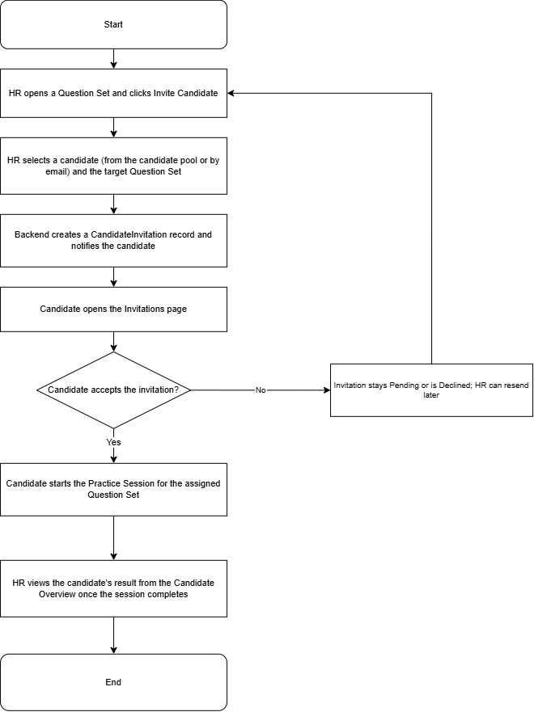

3.7 Workflow 6: HR – Candidate Overview and AI Recommendation
Description: This process describes how an HR user discovers and evaluates candidates who have practiced their question sets. The HR user opens the Candidate Recommendations page, where the Backend computes a list of candidates whose practice activity and skills best match the HR's question sets. Selecting a candidate triggers a consent and eligibility check — the candidate must have allowed recruiter visibility and completed at least one session on one of the HR's own question sets; if not, access is denied. When eligible, the Backend aggregates the candidate's profile, system-wide completed-session statistics, achievement badges, the sets practiced that belong to this HR, and a 52-week practice contribution heatmap, all rendered on a single overview screen so the HR user does not need multiple round-trips. The HR user can bookmark promising candidates for later follow-up.
Workflow Diagram:
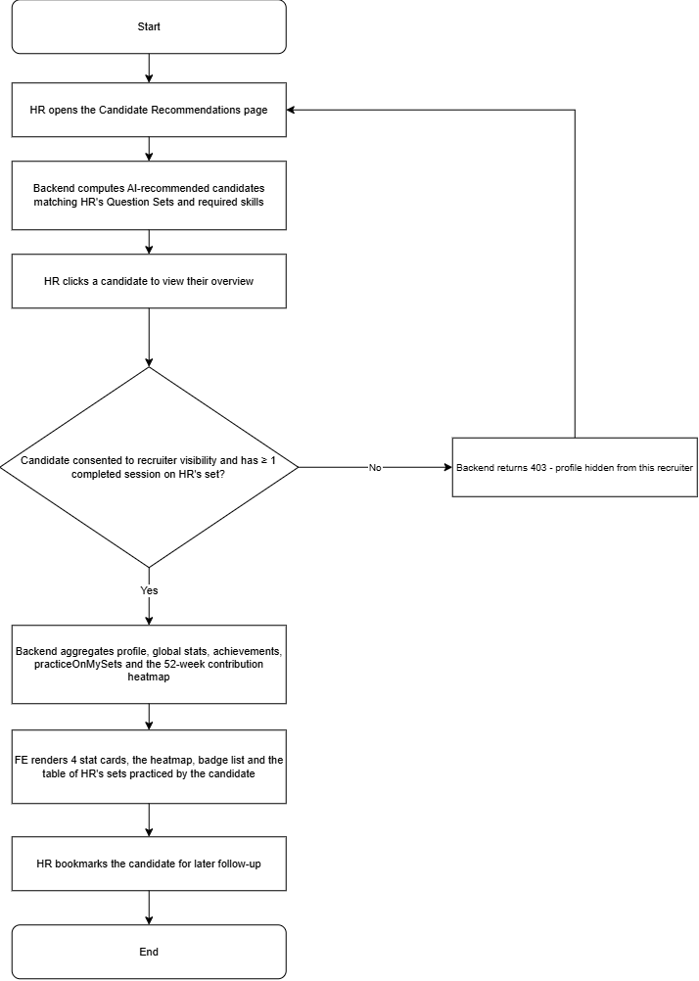

3.8 Workflow 7: Candidate – Upload and AI Parse CV
Description: This process describes how a candidate populates their profile automatically from an existing CV instead of typing everything manually. The candidate uploads a CV file (PDF, DOCX, JPG or PNG, up to 5 MB) from their Profile page; the file is validated client-side first. The Backend forwards the file to the RAG Service's CV-parsing endpoint. For PDF and DOCX files, RAG extracts the raw text and sends it to the LLM's chat-completion endpoint for analysis; for image files, RAG instead encodes the image as base64 and calls Ollama's native vision chat endpoint, since image input is not supported through the OpenAI-compatible interface. Either path returns a structured JSON result containing extracted skills and a short professional summary, which the candidate reviews and confirms on their profile.
Workflow Diagram:
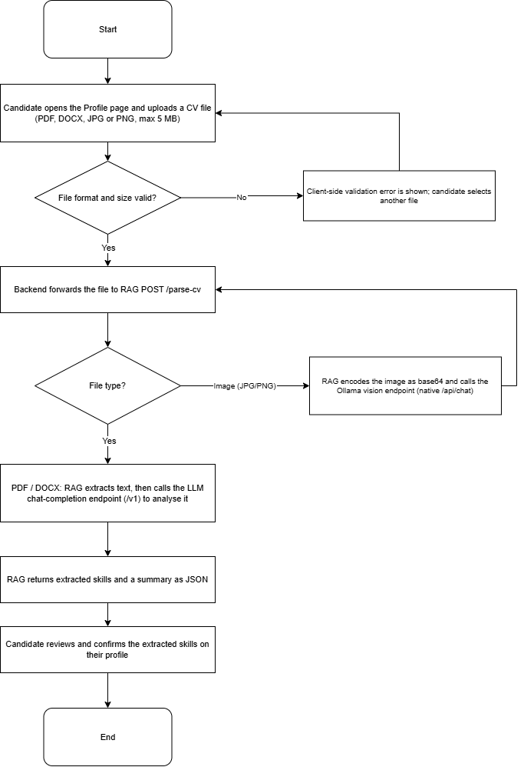

3.9 Workflow 8: Candidate – Browse Marketplace and Start Practice Session
Description: This process describes how a candidate discovers and begins a mock interview. The candidate opens the Practice Marketplace, searches and filters published question sets by role, skill or difficulty, and selects one to start. The Backend creates a Practice Session; Free-tier candidates can see and answer every question in the set. As the candidate answers each question, the answer is saved immediately with evaluationStatus set to Pending — the candidate is never blocked waiting for the AI while taking the test. The session ends either when the candidate clicks Complete or when the configured time limit is reached (an automatic watchdog job submits any session that the candidate leaves unattended), after which the Backend runs the AI batch evaluation described in the next workflow.
Workflow Diagram:
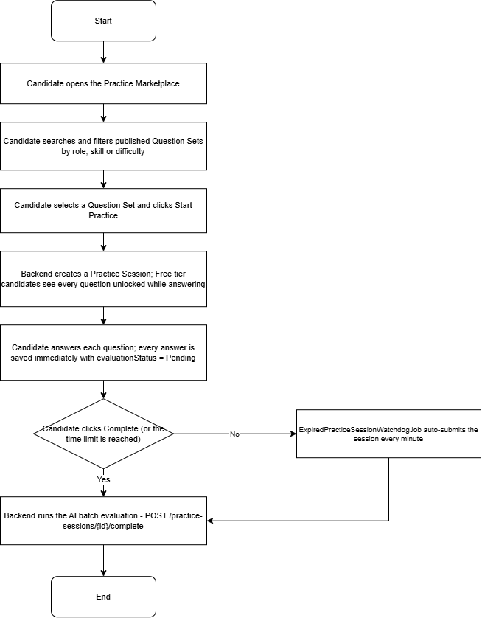

3.10 Workflow 9: Candidate – AI Evaluation and Feedback (Freemium vs Premium)
Description: This process describes how completed practice answers are scored and how the resulting feedback is gated by subscription tier. Once a Practice Session is marked complete, the Backend checks the candidate's subscription. Premium candidates have every answer evaluated by the AI, together with an overall insight and improvement recommendation. Free-tier candidates only have their single longest answer evaluated as a teaser; the overall score is derived from that one question, and the remaining questions stay locked. The resulting feedback is persisted with an access level of either FreeTeaser or Full. When the candidate opens the Feedback page, a FreeTeaser result shows one fully-graded question plus locked placeholders with an upgrade prompt, while a Full result shows AI feedback, a score and rationale for every question along with the overall insight.
Workflow Diagram: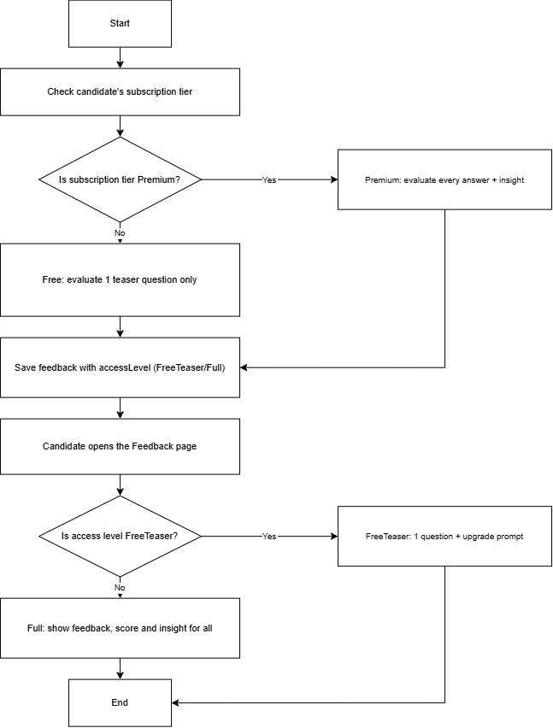

3.11 Workflow 10: Candidate – Dashboard and Practice History
Description: This process describes how a candidate tracks their interview-readiness over time. On the Dashboard, the Backend aggregates a readiness score, a skill radar chart, a KPI grid and a table of the candidate's weakest skills across all completed sessions, along with a 52-week practice contribution heatmap. From Practice History, the candidate can filter past sessions by date or status and open any of them to view the original questions, answers and AI feedback in a read-only view.
Workflow Diagram:
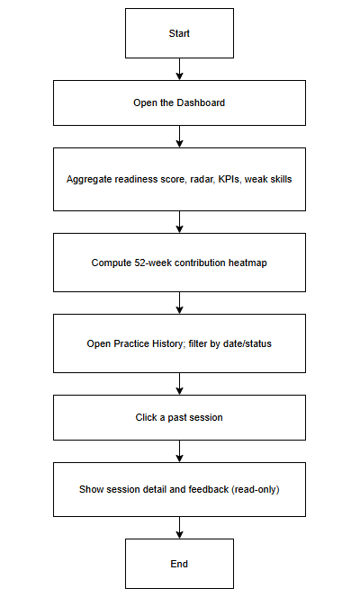

3.12 Workflow 11: Admin – Knowledge Base Oversight and RAG Status Monitoring
Description: This process describes how an administrator supervises the health of the AI pipeline and the shared Knowledge Base. From the Admin Knowledge and RAG Status pages, the Backend lists every knowledge document across both SYSTEM and HR scopes together with its ingest status, and proxies a health check to the RAG Service (database connectivity and configuration validity). If the RAG Service reports unhealthy, the administrator sees an alert and can escalate or restart the service. Documents that remain stuck in PROCESSING beyond a configured threshold are automatically reclaimed and marked FAILED by a recurring watchdog job every 15 minutes, so the administrator does not need to monitor this manually. When a document is no longer needed, the administrator deletes it; the Backend removes the file from Blob Storage and its metadata, then calls the RAG Service to purge the corresponding vector chunks.
Workflow Diagram:
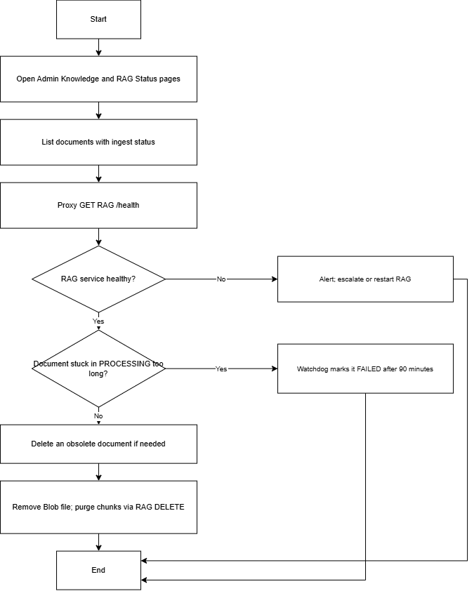

3.13 Workflow 12: Subscription Upgrade and SePay Payment (Realtime Confirmation)
Description: This process describes how an HR or Candidate user upgrades to a paid subscription plan through IQGS's Vietnamese bank-transfer payment integration. The user selects a plan from the Billing/Upgrade page; the Backend creates a pending order through the SePay gateway, returning a VietQR code and a time-to-live for the order, while the frontend simultaneously connects to a per-user SignalR group on the subscription-payments hub. The user scans the QR code and pays via bank transfer; SePay then calls the Backend's webhook endpoint. If the webhook signature is invalid, or the order is no longer pending, the callback is rejected — orders that are never paid are automatically expired by a recurring job every 5 minutes. On a valid, still-pending order, the Backend marks it Paid, activates the subscription, and pushes a PaymentPaid event through SignalR directly to the paying user, who sees the confirmation and gains access to premium features immediately, without needing to poll or refresh the page.
Workflow Diagram:
